**Project Proposal**

1. project value proposition
   1. Stable. The app almost has no mistake or risk.
   2. Convenient. The app is used to provide convenience for the people in a small village.
2. UI SKETCH

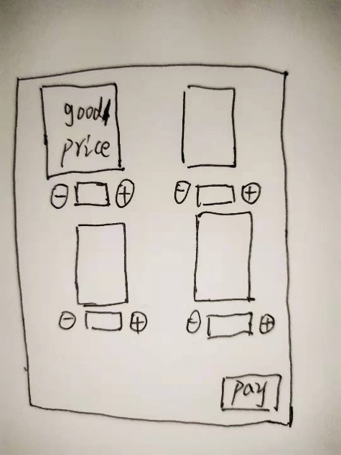 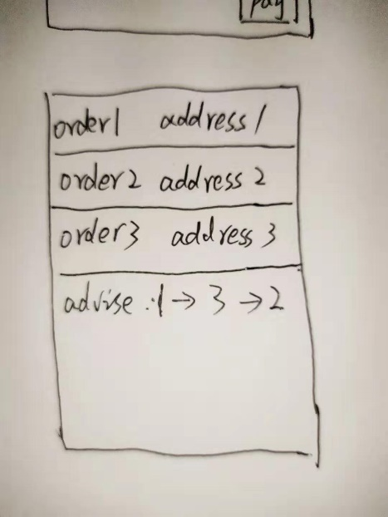

There are two main UI. One is buy the things and the other is to give the advice to deliver goods.

1. System function narrative

It is used to buy the goods from the shops which is in the same village with the user. And it helps the shops take the goods to the user’s house.